

Dream Traveler Agency

Group Members:
Name | Roll No.
Awais Aleem | 223
Ahmed Bilal | 207
Rana Abdullah | 196
Ahmad Raza | 228
Ahsan Abdullah | 213

Course:
AICTL
Instructor Name:
Ramsha Khalid

Date: 29/12/2025
Executive Summary:
Dream Traveler Agency is a static travel-agency website developed using HTML and CSS. The website is designed to promote travel services, tour packages, and customer engagement through a clean and attractive layout. The project focuses on front-end design, proper site structure, and visual consistency while applying basic web-development concepts learned during the course.
Project Objectives & Scope:
Objectives
- To design a professional travel agency website
- To practice HTML page structure and CSS styling
- To improve UI design and navigation skills
Scope
- Static website only (no backend)
- Travel information and service presentation
- Desktop-responsive layout
- Educational project for learning purposes
Site Structure & Navigation:
Page Name | Purpose
Home | Introduction to Dream Traveler Agency
Packages | Travel packages and offers
Services | Agency services
Gallery | Showing the pictures of other country
Contact Us | Contact form and details

Design Choices:
Fonts
- Headings: ‘Poppins’ / Sans-Serif
- Paragraph text: ‘Poppins’ / Sans-Serif
Colors
We use the contrast of Pink and it’s variation.
Layout Decisions
- Sticky header navigation
- Hero section on home page
- Card-based package design
- Flexbox and grid layout for responsiveness
Assets Used:
Images
- Travel destination images
- Background banner images
- Service icons
- Google map
Sources
- Free stock images (Unsplash / Pexels)
- Free icons (Icon libraries)

Exact figures used later
- Total images used: 28
- Total icons used: 7
How to Run / Publish the Site
- Open the project folder
- Double-click home.html
- The website opens in a web browser
OR
- For publishing, upload all HTML, CSS, and asset files to a static hosting service such as GitHub Pages, Netlify, or any web hosting platform supporting static files.
- Ensure relative paths to images and CSS files are correctly maintained.
- The live URL for the deployed site is: https://iawaisaleem.github.io/Group_06-Dream-Traveler-Agency/
QR Code of Website:
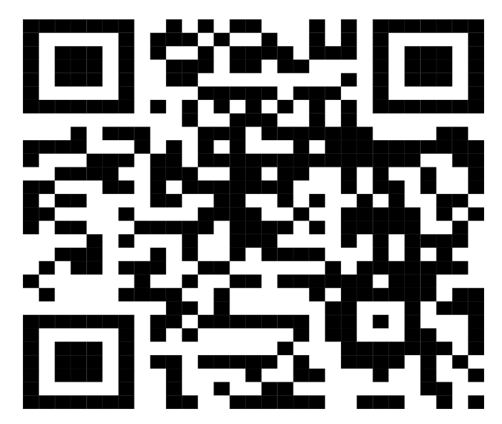

Screenshots:-
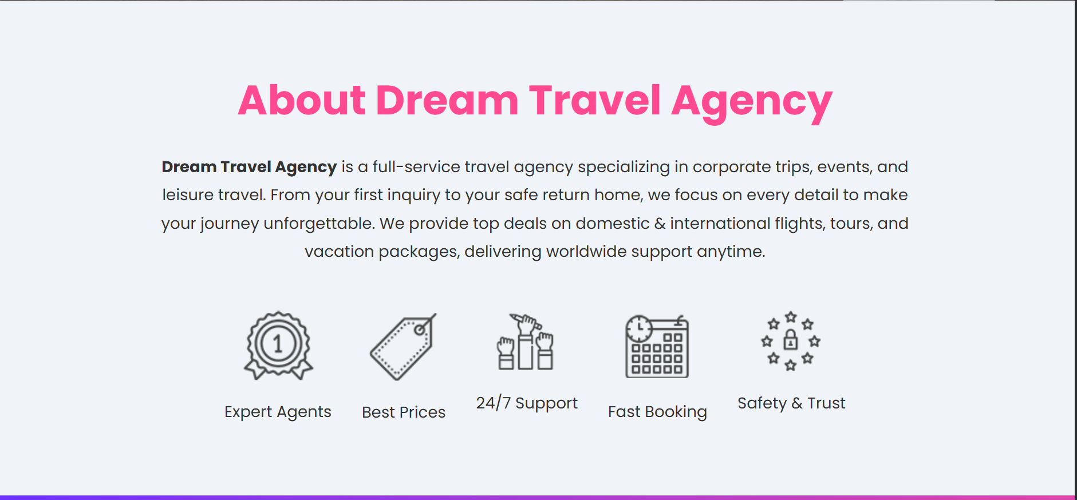
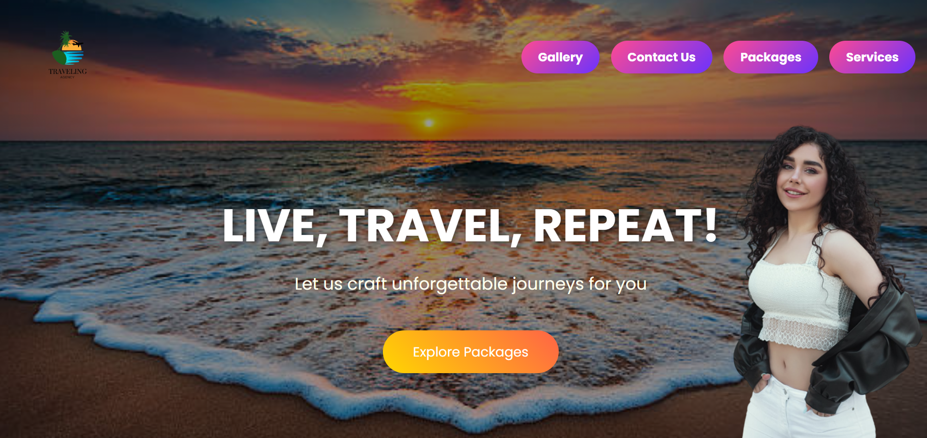
Home:

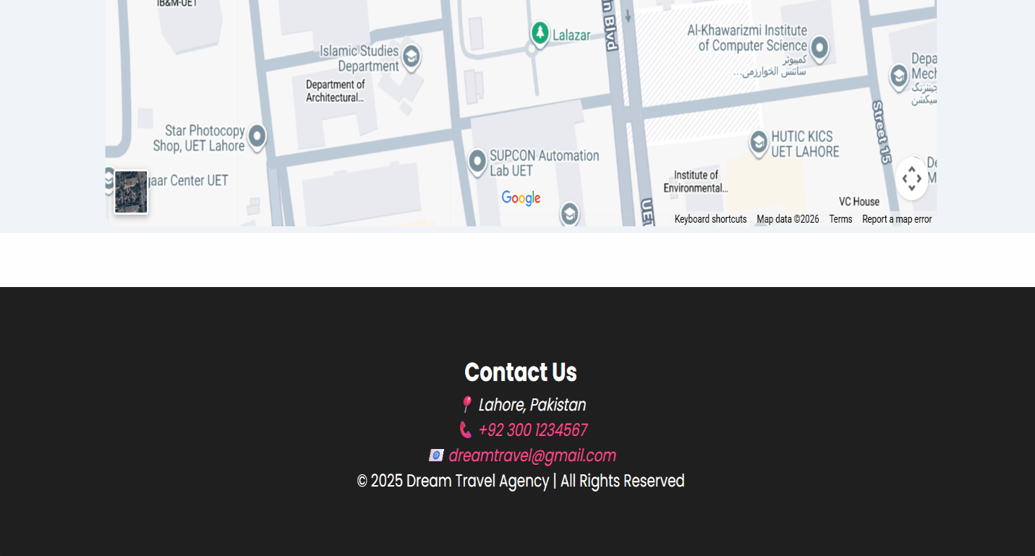
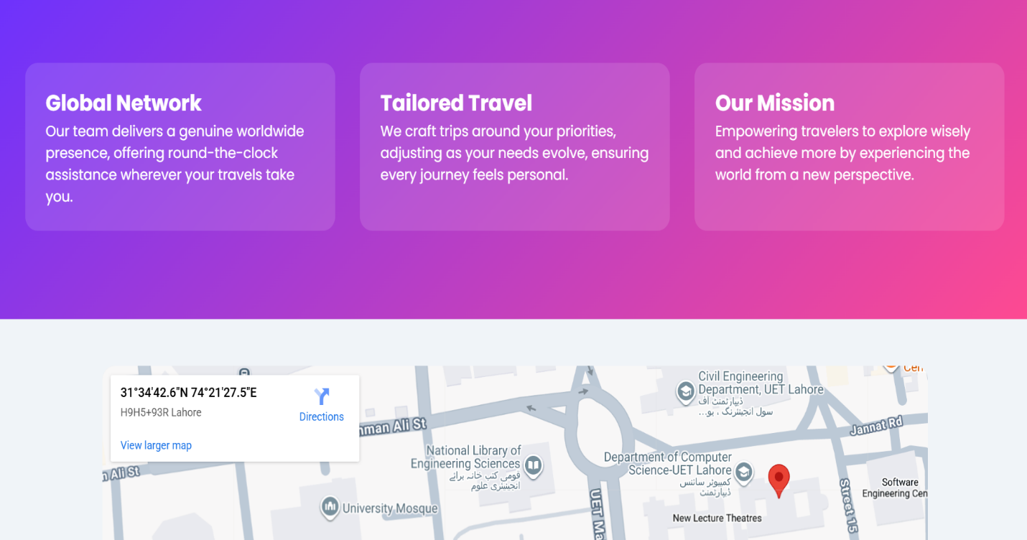

Gallery:
- Aisia-Section:
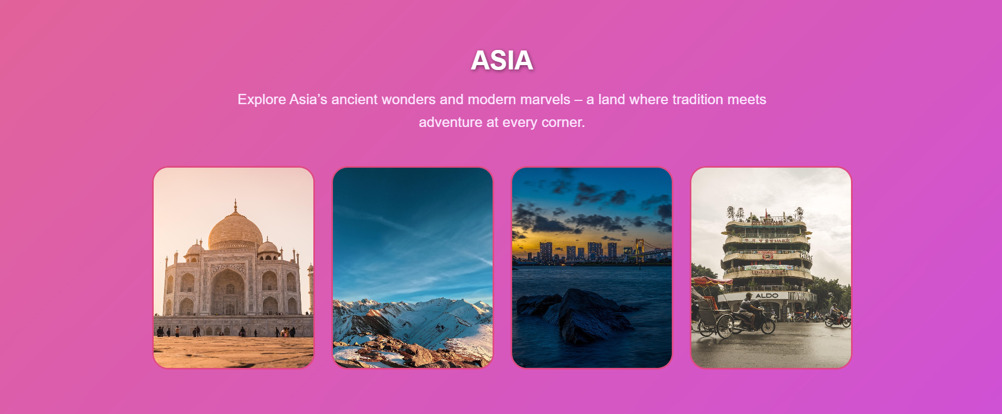
In photots when you move cursor it changes pictures.
- Europe-Section:
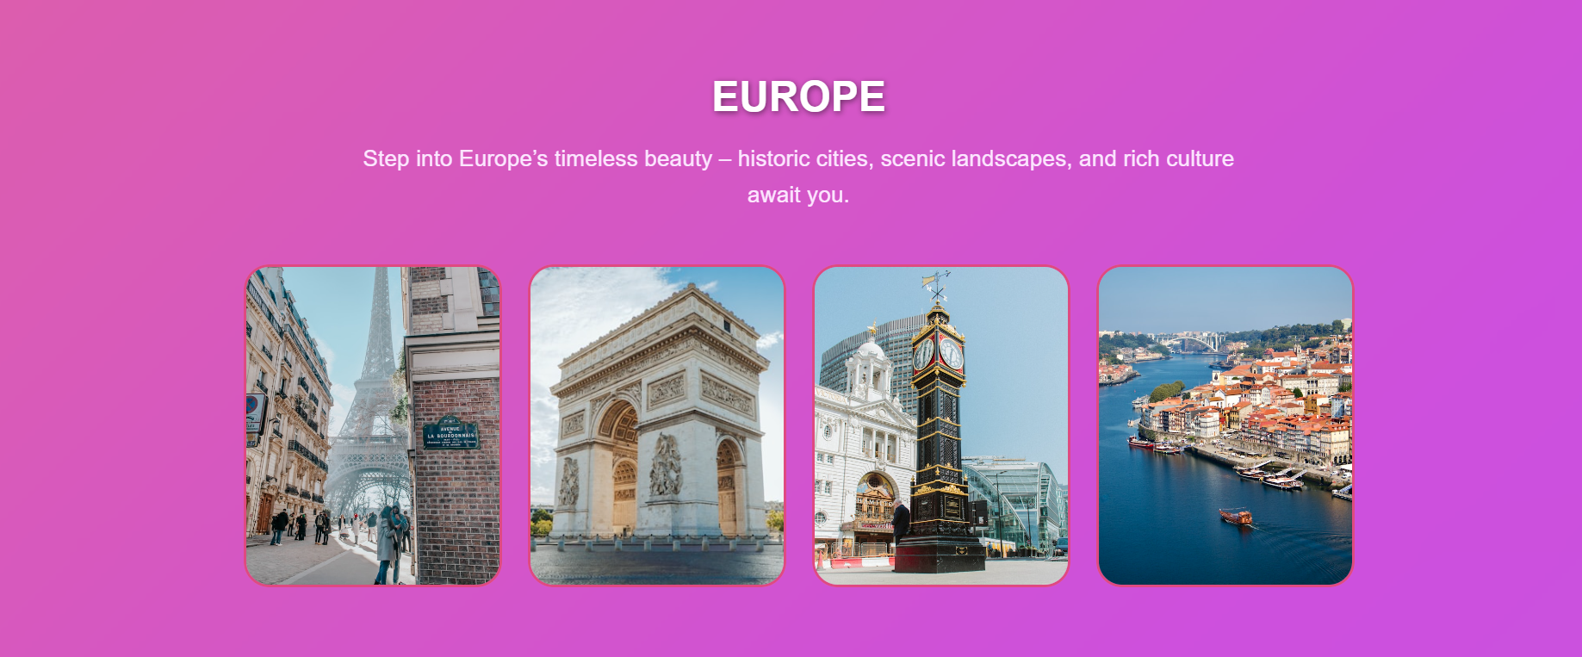
In photots when you move cursor it changes pictures.

- Africa-Section:
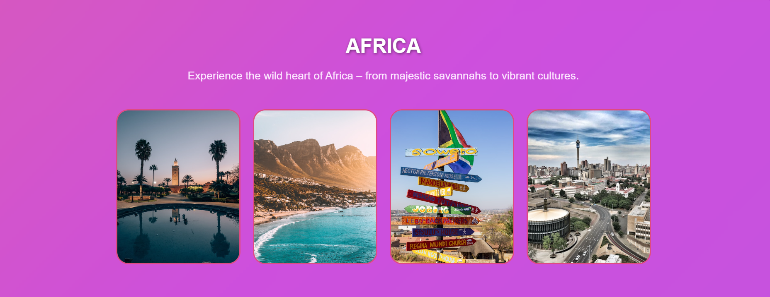
In photots when you move cursor it changes pictures.

- North & South America-Section:
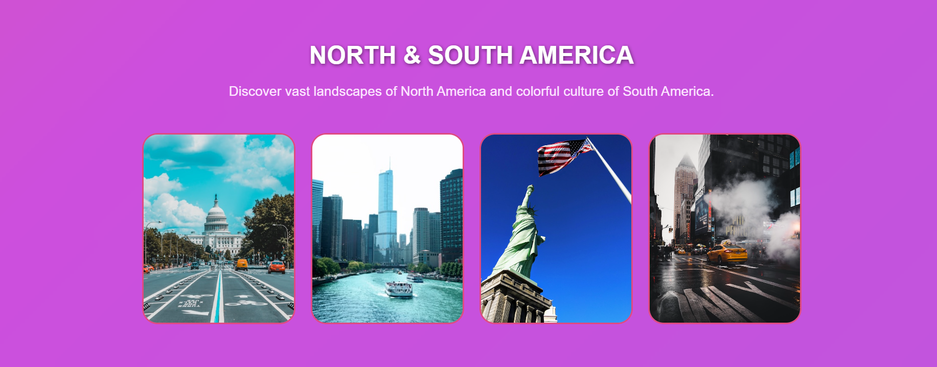
In photots when you move cursor it changes pictures.

- Aurstralia & Oceania-Section:
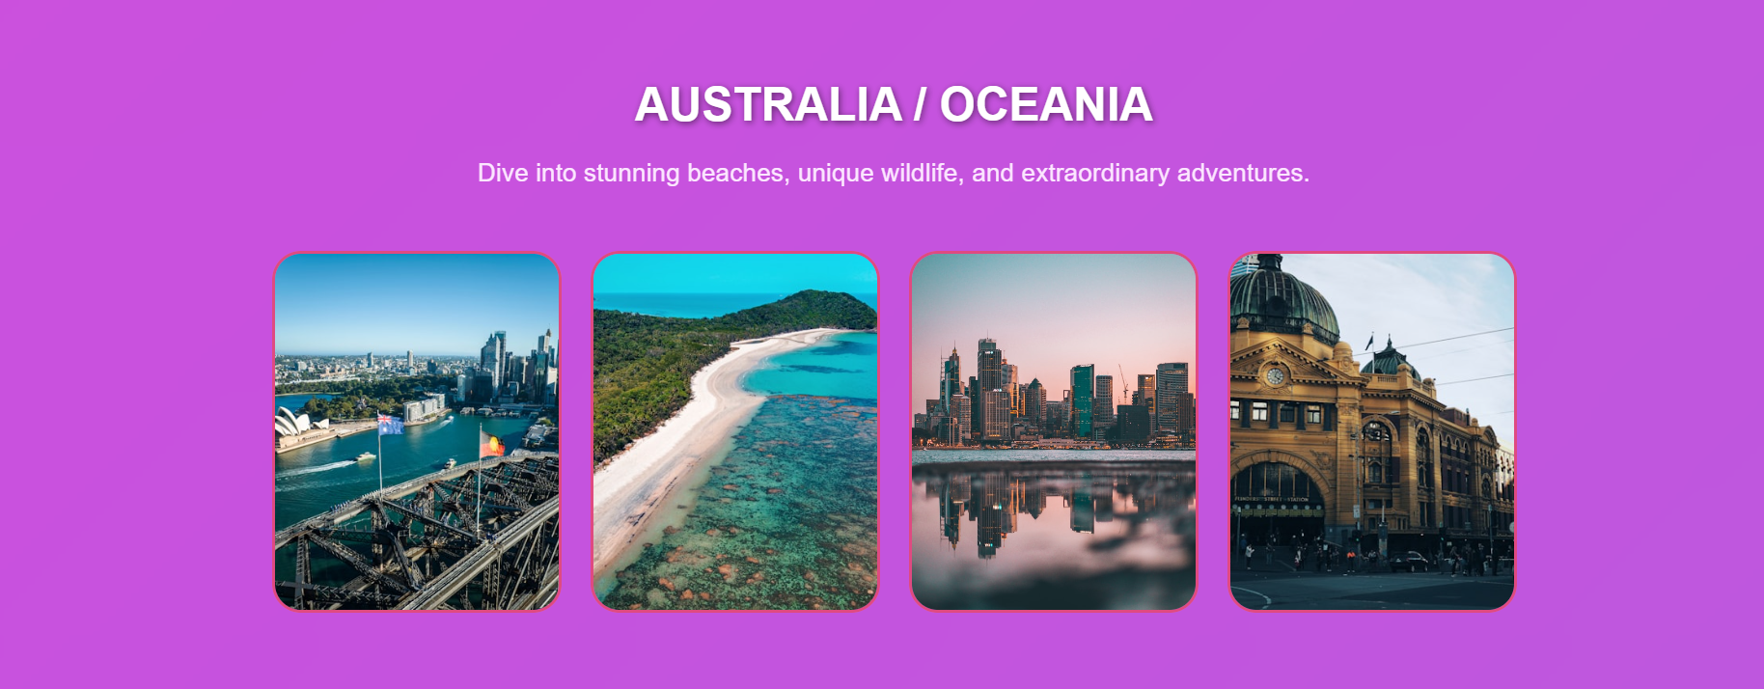
In photots when you move cursor it changes pictures.

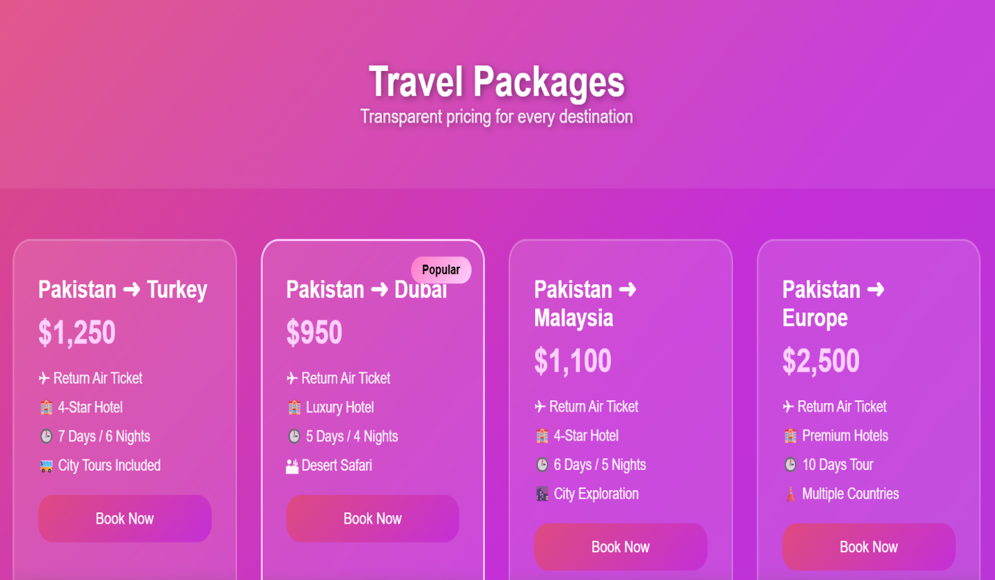
Packages:
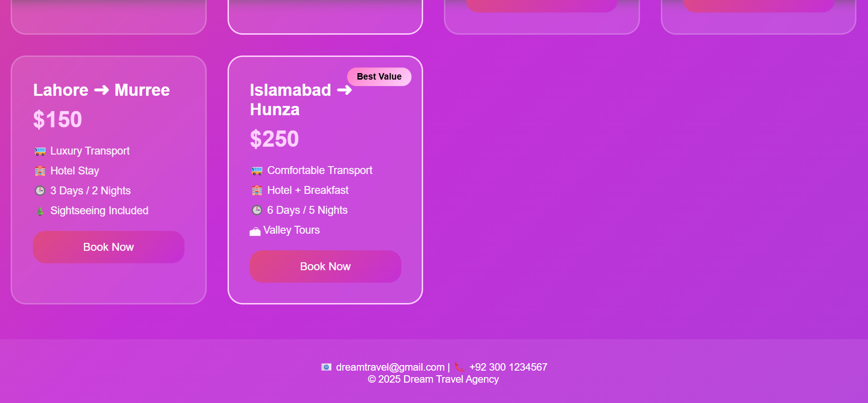
When you on Book now the page take you in contact us button

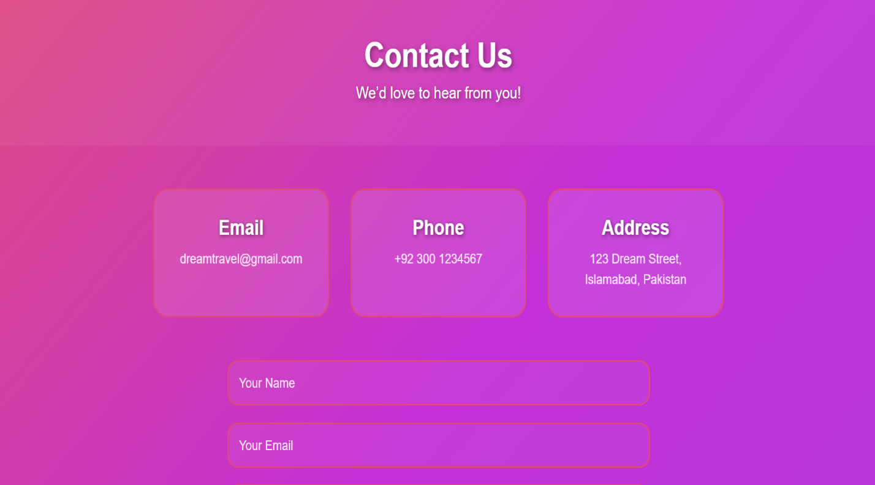
Contact Us:

- Through this page you can contact with agent.

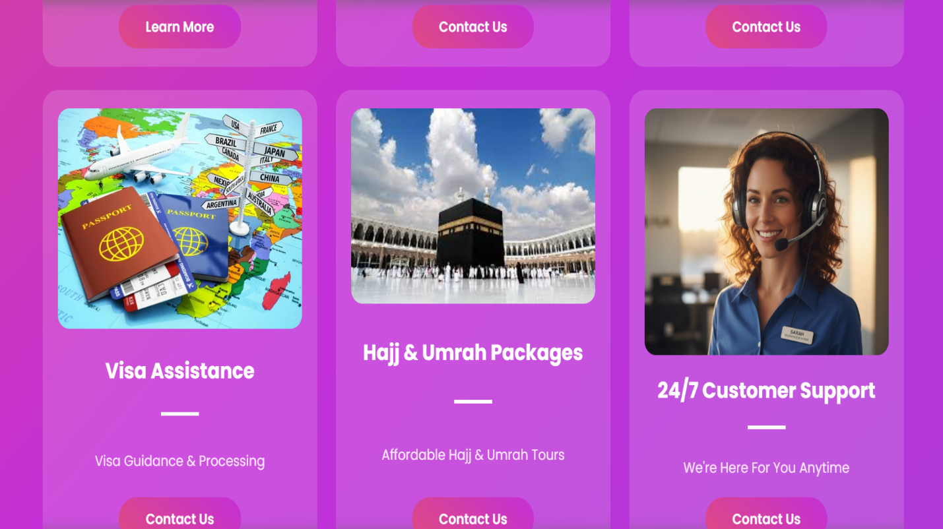
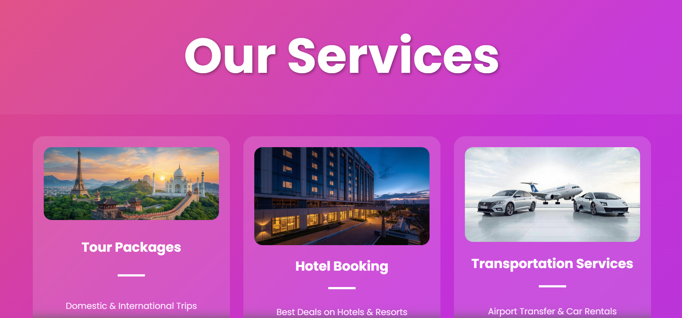
Our Services-Section:

- When you click on Buttons, the page take you in another page
Chart:

- This chart is from Excell which shows the prices of different tours

Reflection
This project helped us understand how to structure a website using HTML and style it effectively using CSS. We learned layout techniques, color selection, and responsive design basics. In the future, the website can be improved by adding JavaScript for interactivity and a backend for booking and user data storage.

